**Advanced level interview Questions React**

## 1)What's the difference between a Controlled component and an Uncontrolled one in React?

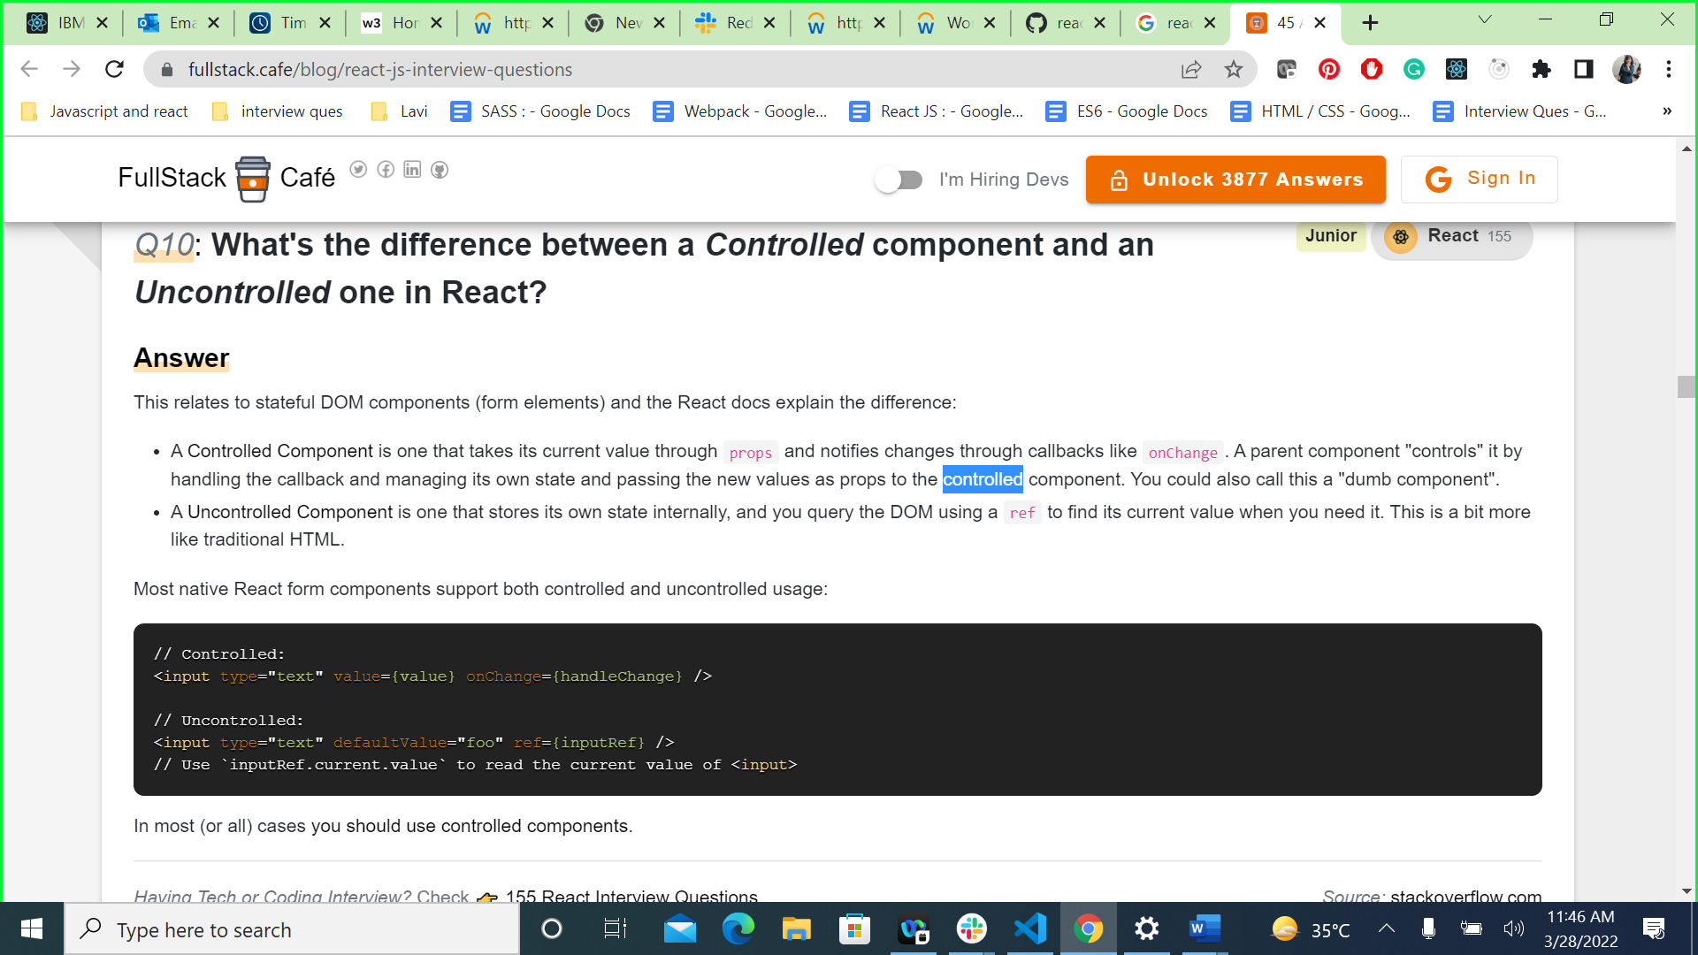

## QUESTION 2

how to get previous state in useEffect AND tell what is ref used for?

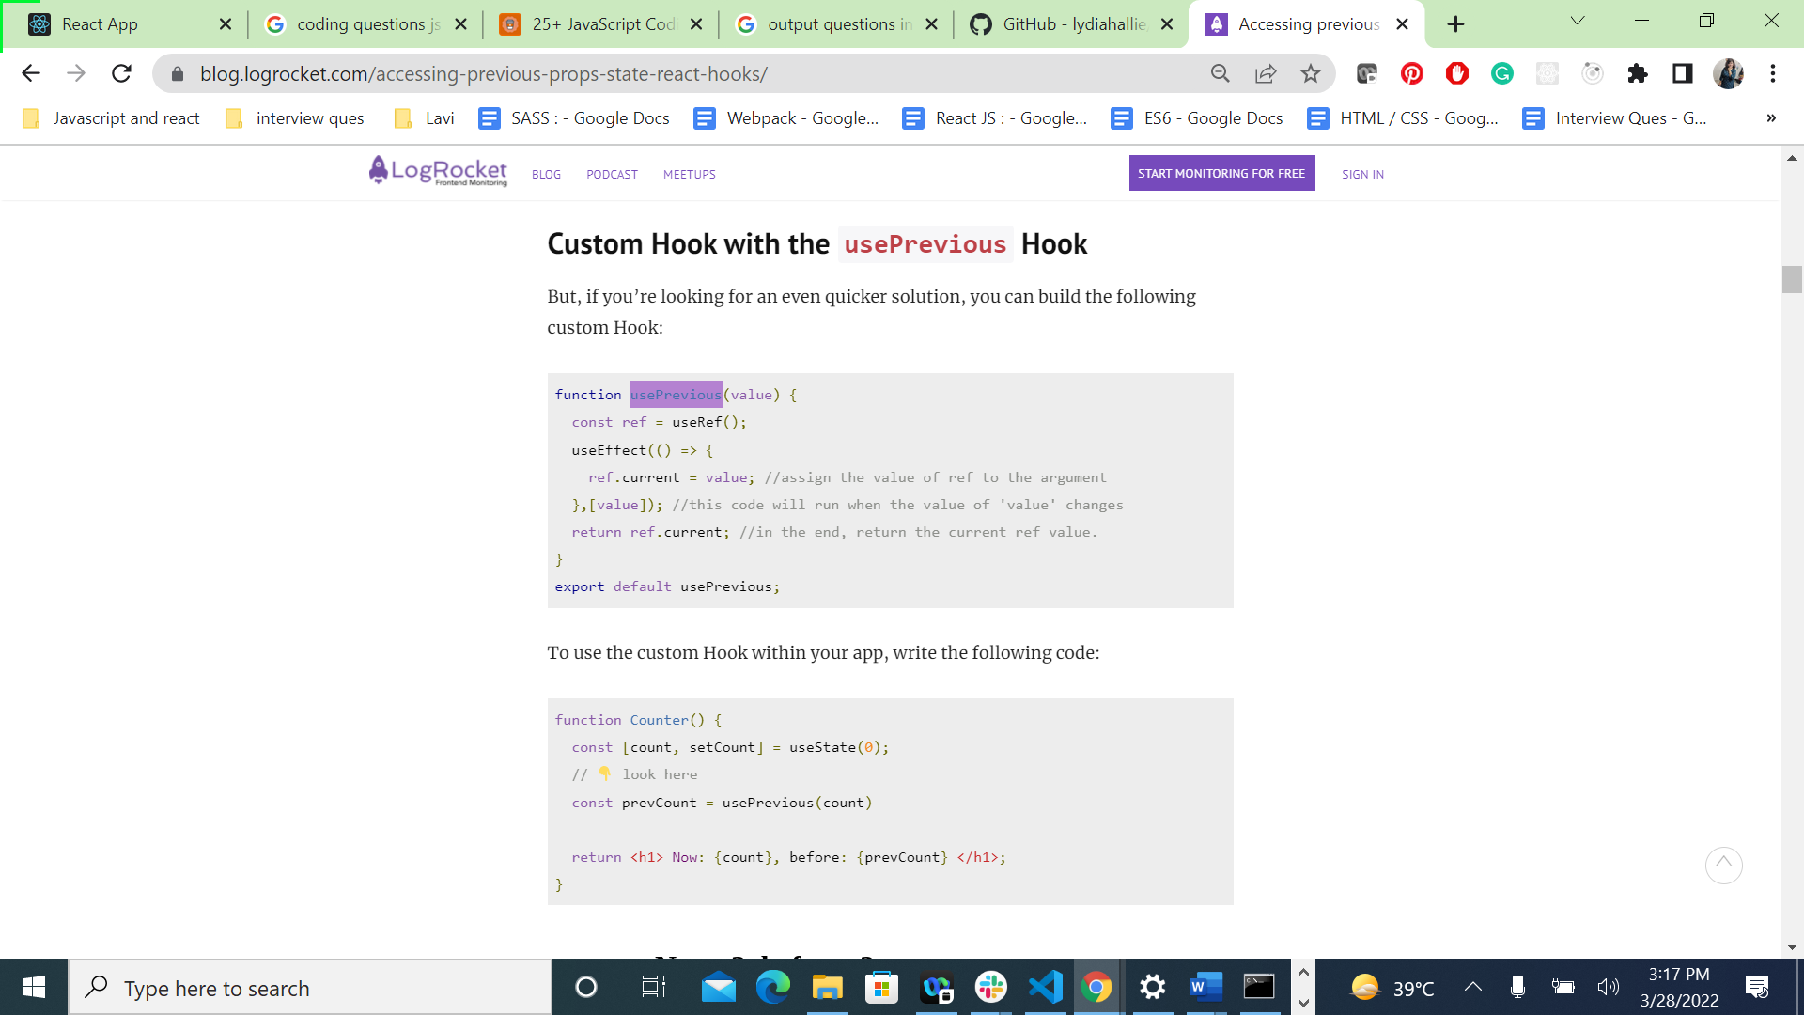

QUESTION 3

What is redux and the explain the components of redux and how it is implemented using react hooks.

And also explain thunk why and for what it is used?

* useDispatch and useSelector

QUESTION 4

What is props drilling ? and can we overcome it ?

provider/consumer - context API

* context api snd parent to chil

QUESTION 5

What is Pure component ?? and in functional react component what do we use ??

QUESTION 6

Error boundries in react:

getDrivedstateFromError and componentDidCatch

QUESTION 7

render vs hydrate vs commit

QUESTION 8

WHAT is **Code-splitting and techniques for it?**

**Ans---**

* **The best way to introduce code-splitting into your app is through the dynamic import() syntax**

**import("./math").then(math => {**

**console.log(math.add(16, 26));**

**});**

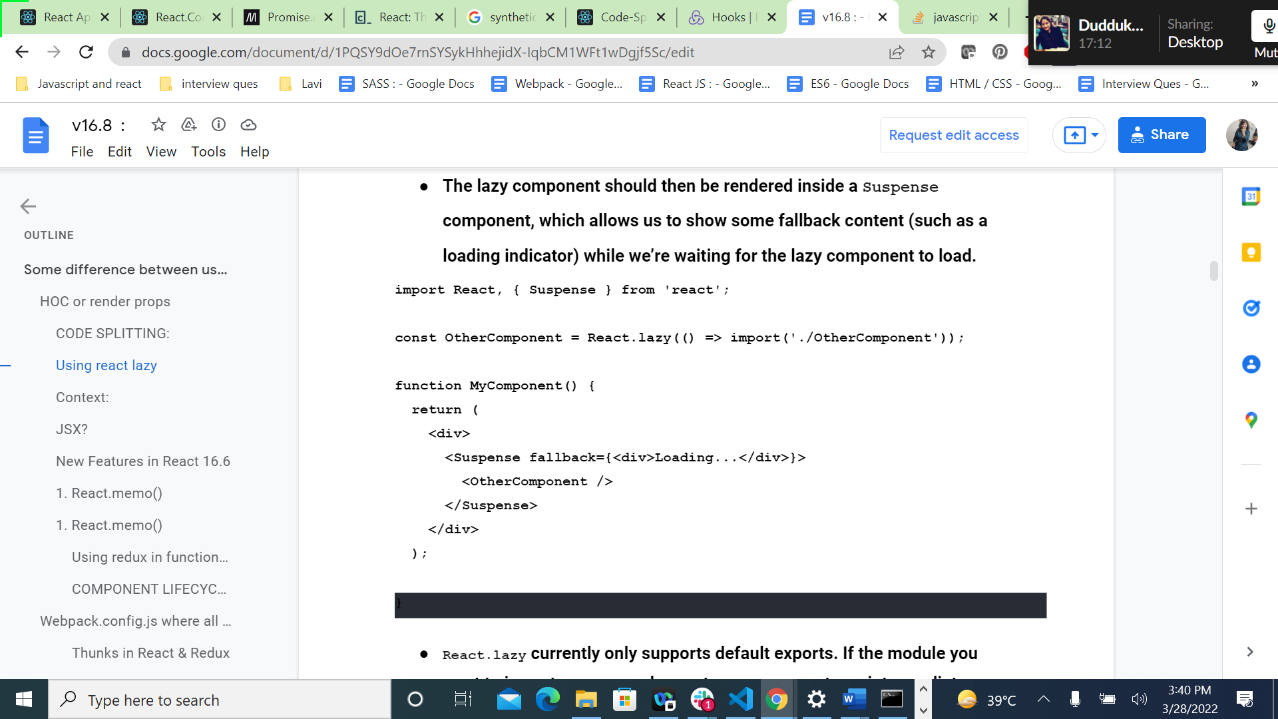

QUESTION 9

WHAT IS HOC (HIGHER ORDER COMPONENT) give example.

QUESTION 10

What are synthetic events? And what are service workers and web workers?

QUESTION 11

How react works ? explain concept and algo used in concept of virtual DOM